**Torn From Within:**

The African-American Family Epidemic

By

Ivan Page, Ph.D.

**It is within the family environment we learn values, morals, and standards of behavior.**

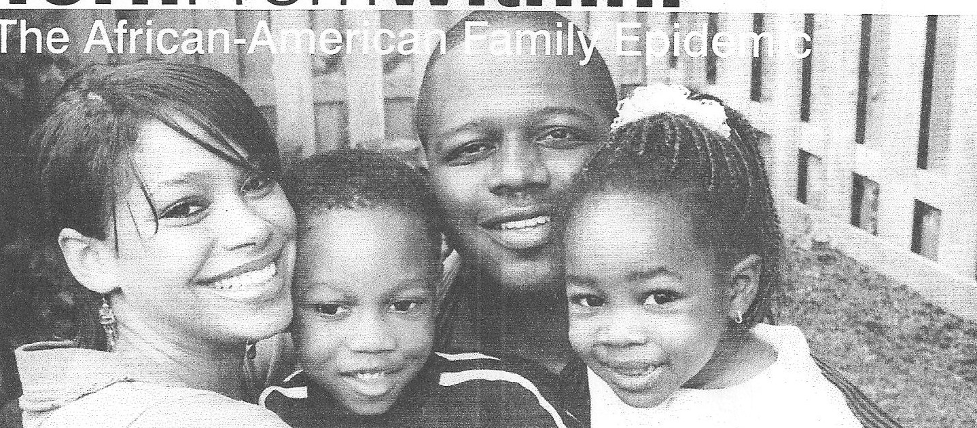

**Introduction**

In 1965, Daniel Patrick Moynihan (then Assistant Labor Secretaty) sounded an alarm by revealing that 25 percent of African-American households were headed by single mothers. The African-American community was forced to take notice of a persistent problem that existed for quite some time—the breakdown of the African-American family due to the disappearing father. Fast forward to 2011, a resounding cry can still be heard within the African-American community now facing households where approximately 54 percent are headed by single parent—most by women.

Too many young African-American women are having children early

without getting married. Young men and women are engaging in sexual relations

as early as 12 years old. Not fully understanding the ramifications of such issues

as parental responsibilities, the possibility of contracting a sexual transmitted

disease, completing high school, and securing employment; too often they become

trapped in a life of poverty.

**The Family Value Issues**

There has been a consistent erosion of values in the African-American

community. Sociologist Charles Horton Cooley suggests that the family is

responsible for the socialization process. It is within the family environment we

learn values, morals, and standards of behavior. According to Cooley, the family is

every society’s most important social group and the first group we experience in

life. The lack of a stable family structure simply results in the development of

standards inconsistent with functioning in a progressive society. Working for the

essential things one needs for survival and setting life goals are just some examples

of skills missing when the socialization process goes wrong. The results are,

individuals lacking the moral fortitude to compete and function in society.

Often it is difficult for a single mother to fully ensure that her teenagers

are coming home after school, completing homework assignments, and performing required chores and not engaging in potentially immoral or dangerous behaviors

such as sexual activity or illegal drug use. Too often, single mothers are tired after

work and cannot fully monitor the behavior of their children. Many two-parent

households I speak with discuss a system of working together to monitor the

behavior of their children. This system, which I call the parental responsibility tag

team approach, does not allow one parent to burn out while teaching and

reinforcing acceptable standards of behavior.

**Social workers need help to address issues confronting the African American community.**

African-American men seem to be hampered by what I believe is best

described by the concept “failure to commit.” This view of African-American men failing to commit to a stable relationship or marriage is shared by many women I interviewed throughout Atlanta, GA. They identified two concerns: perceived power and fear of responsibility. More and more men are remaining single and dating a variety of women,

which they find empowering and helping them to avoid responsibilities that come with marriage. It also bring emotional protection from getting attached to a particular woman if the relationship doesn’t last.

**Possible Solutions**

Oddly enough, solutions to the African-American family epidemic lie in reclaiming

values from the past. First, the church must become the focal point in our community again. As during the civil rights struggle, the church must take the lead in the political, economic, and social stability of the family. Once again the church must be the catalyst for the development and stability of the African-American community.

Second values and expectations that were taught in the past must reappear. Growing up in the 1960s and 1970s, I was expected to respect people’s property, go to Sunday school, graduate from high school and not get a woman pregnant without being married to her. Good values and expectations must be generational.

Finally, reckless behavior must be the exception not the norm for the African-American

man and woman. As Judge Greg Mathis suggests in his article “Black Men Fight Back Against Obstacles,” African-American men must resist the self destructive lifestyles that hurt our families and community. Both men and women must be more committed and responsible for their actions. It is time for African-American men and women to make critical decisions about their relationship, family, and commitment to a spiritual life.

References

Leigh W.A. (2007). What's it going to take? Extending the research base to improve teen, pregnancy. Retrieved from Web site: http ://www.teen re anc .or resources/research/researchcon/lei abstract. df on August 27, 2000.

Macionis, J. (2007). 12th ed. Sociology. Pearson Prentice Hall. Upper Saddle River: New Jersey.

Mathis, G. (2007, February). Black men must fight back against obstacles. Ebony Magazine. p.38.

Wooten, J. (2007, November 25). Nation's Children being harmed by unmarried adults. Atlanta Journal Constitution. p. B.6.

(N .A.). Adolescent pregnancy and childbearing in the United States. Retrieved from Web site: *htt2:11~* .advocatesforyouth.org/PUBLICA TIONS/factsheet/fsprechd.htm on August 27, 2008.

(N.A.). African-American adolescents: Living in a high-risk population. Retrieved from Web site: http://ww.idRh.state.i!.us/Rublic/resDectiAfrican American fs.htm on August 27, 2008.